**AWS Report**

**Screenshots:**

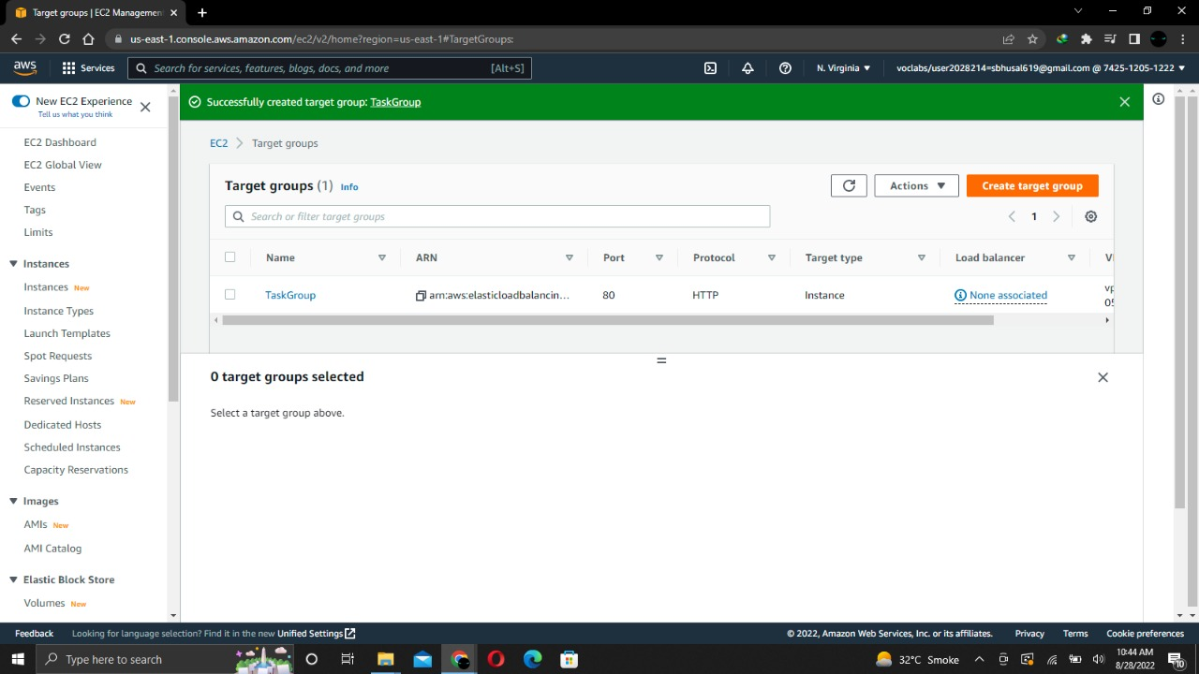

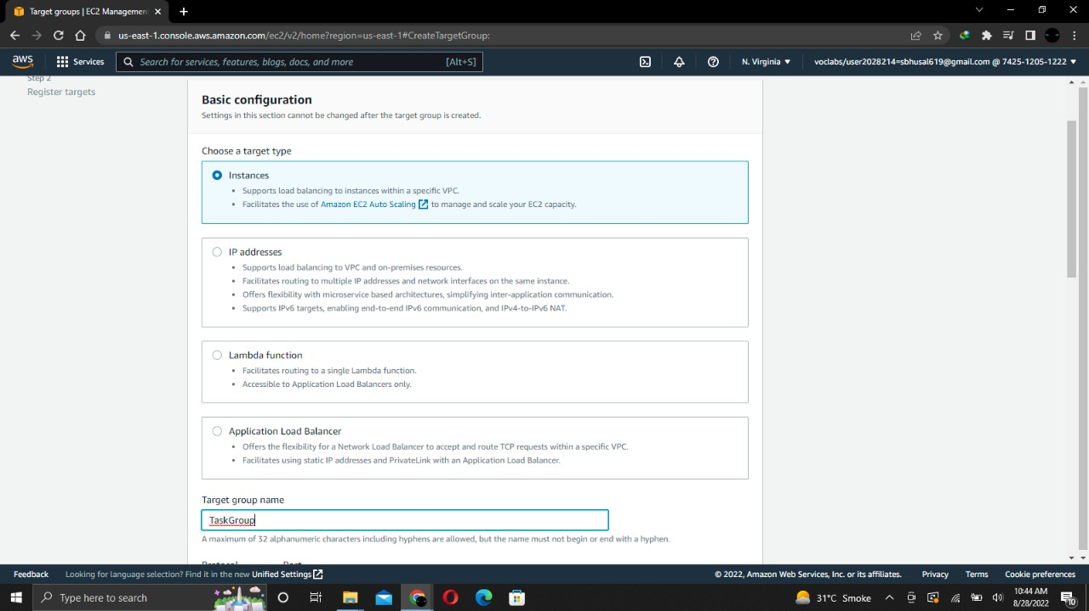

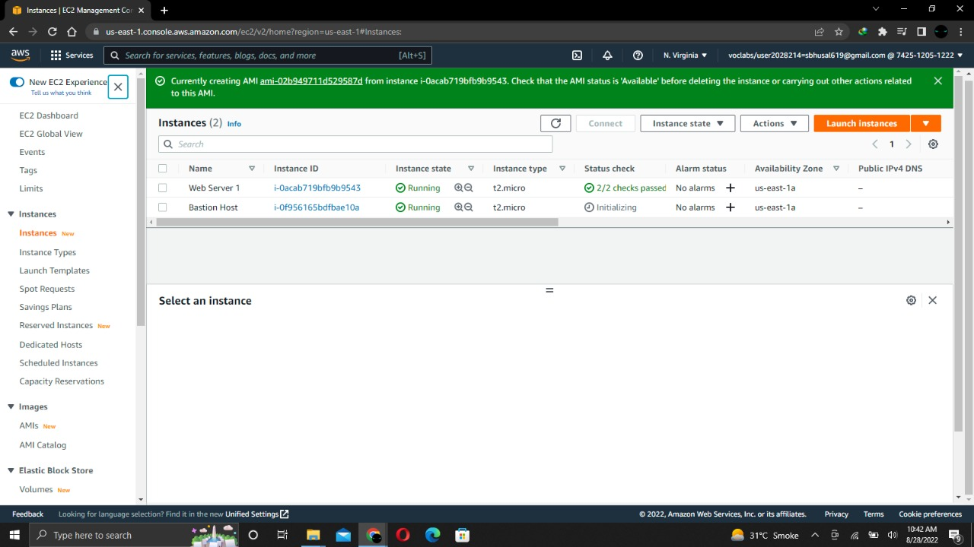

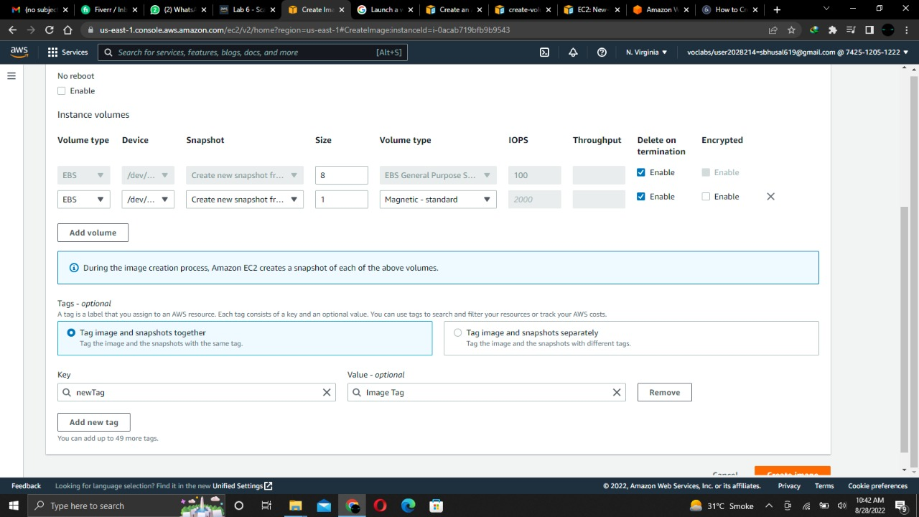

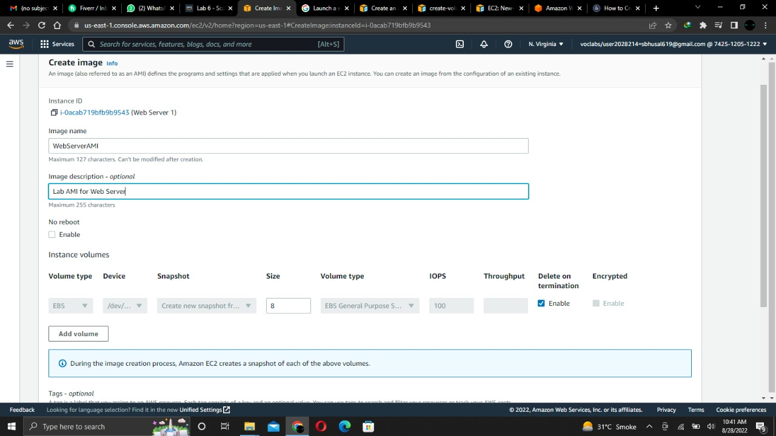

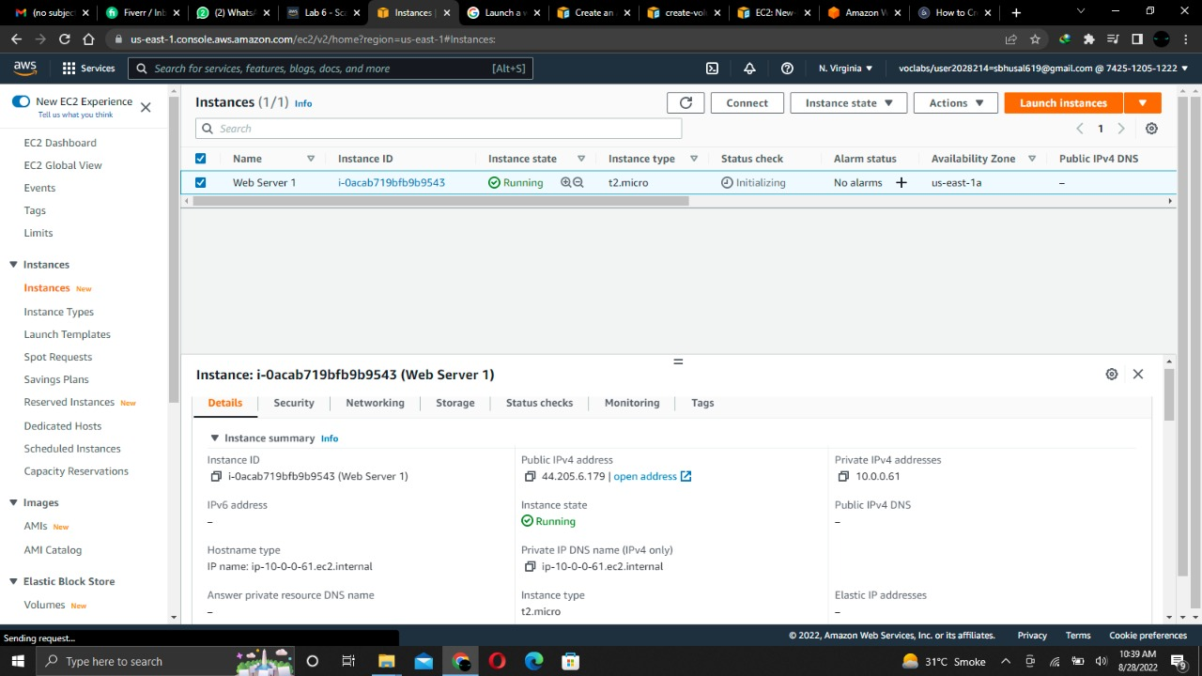

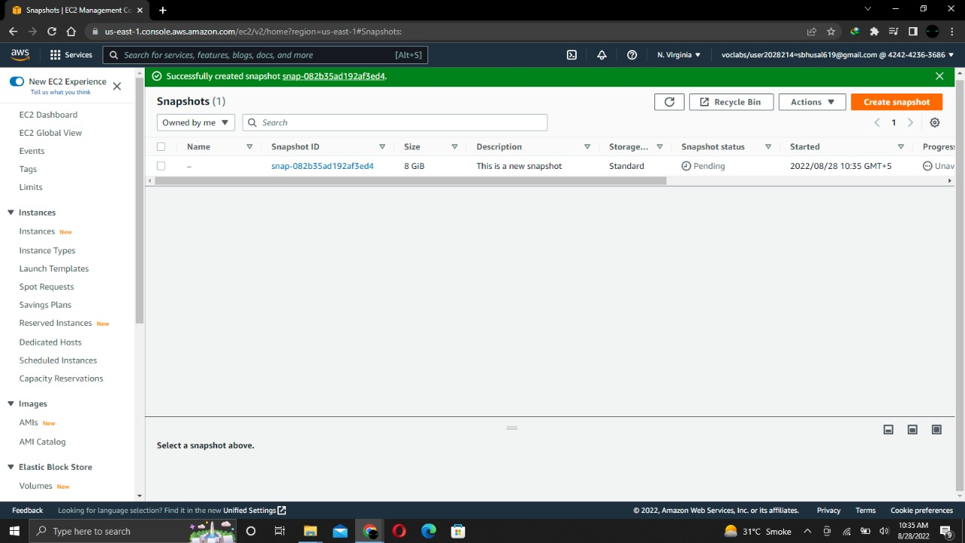

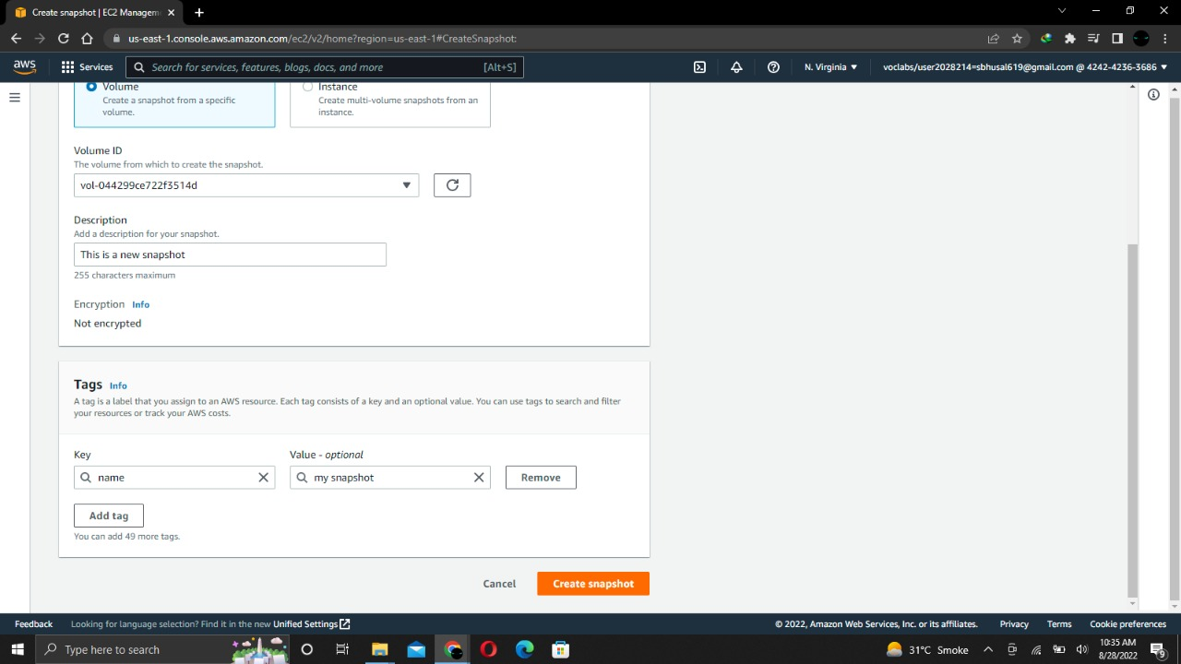

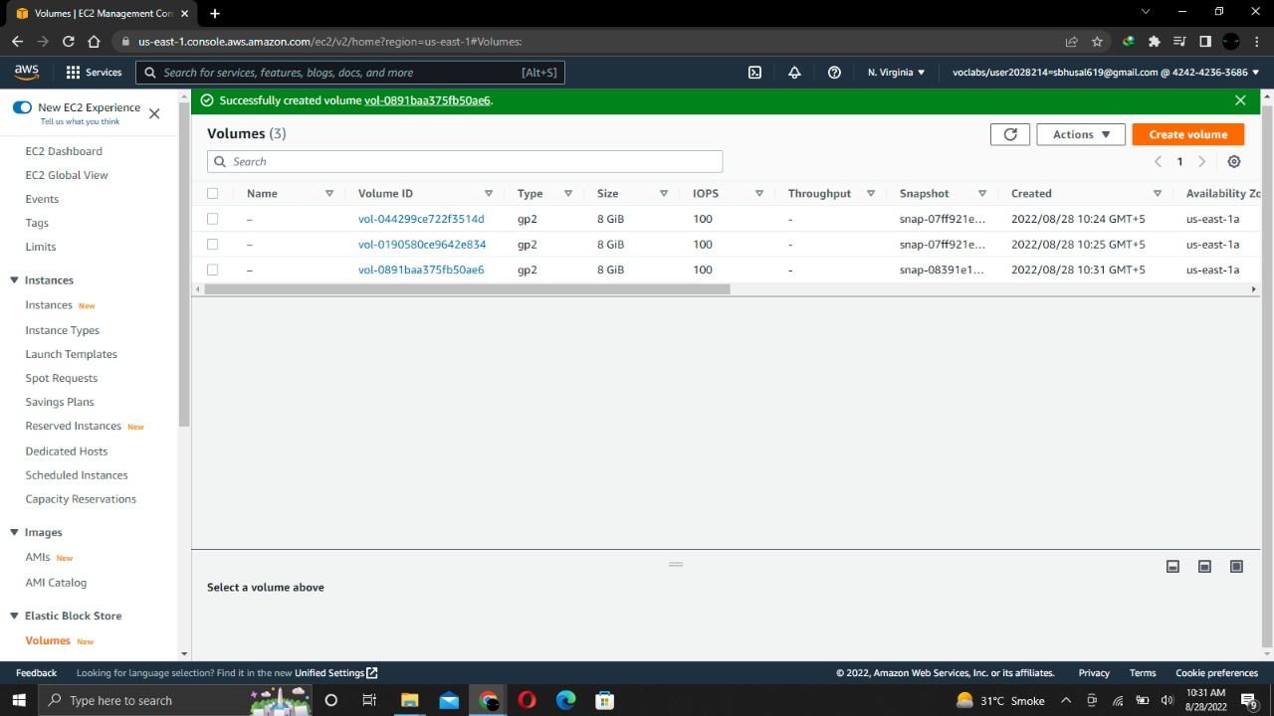

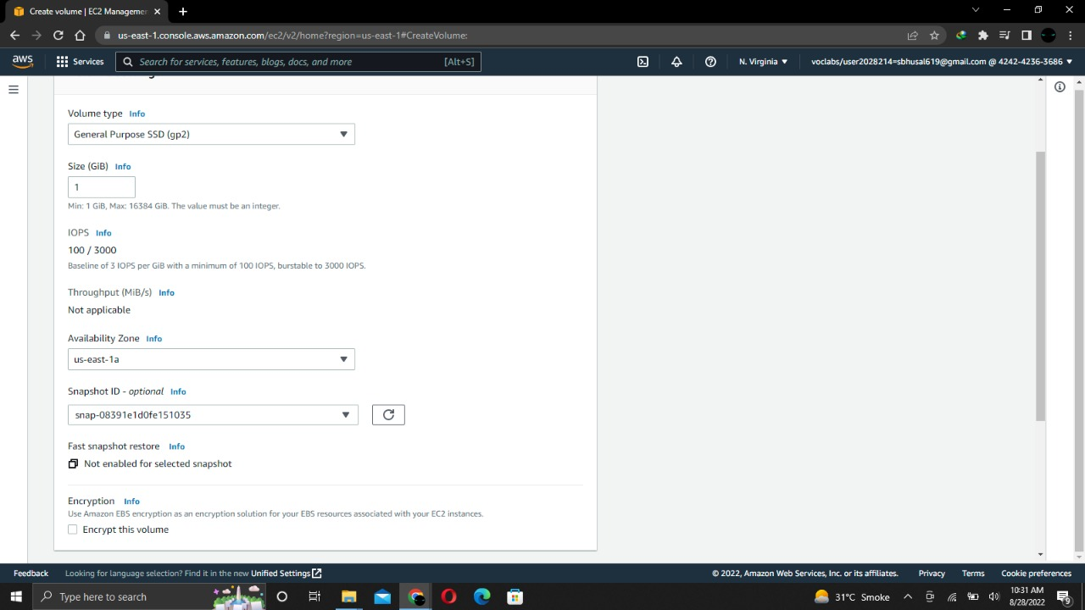

**Analysis:**

Amazon EC2 Auto Scaling helps you with staying aware of utilization openness and grants you to therefore add or wipe out EC2 cases according to conditions you portray. You can utilize the armada the board highlights of EC2 Auto Scaling to keep up with the wellbeing and accessibility of your armada. You can likewise utilize the dynamic and prescient scaling highlights of EC2 Auto Scaling to add or eliminate EC2 occurrences. Dynamic scaling answers changing interest and prescient scaling naturally plans the right number of EC2 examples in view of anticipated request. Dynamic scaling and prescient scaling can be utilized together proportional quicker.

* **Improve fault tolerance**

Amazon EC2 Auto Scaling can recognize when an occurrence is undesirable, end it, and supplant it with another one.

* **Increase application availability**

Amazon EC2 Auto Scaling guarantees that your application generally has the perfect proportion of process, and furthermore proactively arrangements limit with Predictive Scaling.

* **Lower costs**

Amazon EC2 Auto Scaling adds occasions just when required, and can scale across buy choices to enhance execution and cost.

**Fleet Management:**

Whether you are running one Amazon EC2 occasion or thousands, you can utilize Amazon EC2 Auto Scaling to recognize disabled Amazon EC2 cases and undesirable applications, and supplant the examples without your mediation. This guarantees that your application is getting the process limit that you anticipate. Amazon EC2 Auto Scaling will carry out three principal roles to computerize armada the executives for EC2 occasions:

* **Monitor the health of running instances**

Amazon EC2 Auto Scaling guarantees that your application can get traffic and that EC2 cases are working appropriately. Amazon EC2 Auto Scaling occasionally performs wellbeing checks to distinguish any occurrences that are undesirable.

* **Repaired impaired instance automatically**

At the point when a weakened case bombs a wellbeing check, Amazon EC2 Auto Scaling consequently ends it and replaces it with another one. That implies that you don't have to answer physically when an occasion needs supplanting.

* **Balance capacity across availability zones**

Amazon EC2 Auto Scaling can naturally adjust occurrences across zones, and consistently dispatches new occasions with the goal that they are adjusted between zones as equally as conceivable across your whole armada.

**Scheduled scaling:**

Scaling in light of a timetable permits you to scale your application in front of realized load changes. For instance, consistently the traffic to your web application begins to increment on Wednesday, stays high on Thursday, and begins to diminish on Friday. You can design your scaling exercises in view of the realized traffic examples of your web application.

**Dynamic scaling:**

Amazon EC2 Auto Scaling empowers you to follow the interest bend for your applications intently, decreasing the need to arrangement Amazon EC2 limit ahead of time physically. For instance, you can utilize target following scaling strategies to choose a heap metric for your application, like CPU usage. Or on the other hand, you could set an objective worth utilizing the new "Solicitation Count Per Target" metric from Application Load Balancer, a heap adjusting choice for the Elastic Load Balancing administration. Amazon EC2 Auto Scaling will then, at that point, naturally change the quantity of EC2 cases depending on the situation to keep up with your objective.

**Predictive scaling:**

Prescient Scaling, presently locally upheld as an EC2 Auto Scaling strategy, utilizes AI to plan the right number of EC2 occasions fully expecting moving toward traffic changes. Prescient Scaling predicts future traffic, including routinely happening spikes, and arrangements the right number of EC2 occurrences ahead of time. Prescient Scaling's AI calculations distinguish changes in everyday and week after week designs, naturally changing their figures. This eliminates the requirement for manual change of Auto Scaling boundaries as cyclicality changes over the long run, making Auto Scaling more straightforward to design. Auto Scaling upgraded with Predictive Scaling conveys quicker, less complex, and more precise limit provisioning bringing about lower cost and more responsive applications.

**Considerations for compatible instance type:**

You should stop your Amazon EBS-upheld case before you can change its example type. Guarantee that you plan for free time while your case is halted. Halting the case and changing its example type could require a couple of moments, and restarting your occasion could take a variable measure of time contingent upon your application's startup scripts. For more data, see Stop and begin your case.

At the point when you pause and begin a case, we move the occasion to new equipment. In the event that your case has a public IPv4 address, we discharge the location and give your occasion another public IPv4 address. On the off chance that you require a public IPv4 address that doesn't change, utilize an Elastic IP address.

You can't change the case type assuming that hibernation is empowered for the example.

You can't change the case kind of a Spot Instance.

In the event that your case is in an Auto Scaling bunch, the Amazon EC2 Auto Scaling administration denotes the halted occasion as undesirable, and may end it and send off a substitution occurrence. To forestall this, you can suspend the scaling processes for the gathering while you're changing the case type. For more data, see Suspending and continuing a cycle for an Auto Scaling bunch in the Amazon EC2 Auto Scaling User Guide.

At the point when you change the example kind of an occasion with NVMe case store volumes, the refreshed occurrence could have extra occasion store volumes, since all NVMe case store volumes are accessible regardless of whether they are not determined in the AMI or occasion block gadget planning. In any case, the refreshed occasion has a similar number of example store volumes that you determined when you sent off the first occurrence.

**Change the instance type by launching a new instance:**

If the ongoing setup of your EBS-upheld example is inconsistent with the new occasion type that you need, then you can't change the occurrence sort of the first case. All things considered, you should send off another occurrence with a setup that is viable with the new case type that you need, and afterward relocate your application to the new example. For instance, assuming that you sent off your unique case from a PV AMI, yet need to change to an ongoing age occasion type that is just upheld by a HVM AMI, you'll have to send off another example from a HVM AMI. For data about how not entirely set in stone, see Compatibility for changing the example type.

To relocate your application to another occurrence, do the accompanying:

Back up the information on your unique occurrence.

Send off another occurrence with a setup that is viable with the new example type that you need, and join any EBS volumes that were connected to your unique occasion.

Introduce your application and any product on your new occasion.

Reestablish any information.

Assuming your unique occasion has an Elastic IP address, and you need to guarantee that your clients can proceed continuous to utilize the applications on your new example, you should relate the Elastic IP address with your new occurrence. For more data, see Elastic IP address.

**Conclusion:**

Virtual processing conditions, known as occasions

Preconfigured layouts for your occasions, known as Amazon Machine Images (AMIs), that bundle the pieces you really want for your server (counting the working framework and extra programming)

Different setups of CPU, memory, stockpiling, and systems administration limit with regards to your cases, known as occurrence types

Secure login data for your cases utilizing key matches (AWS stores the public key, and you store the confidential key in a solid spot)

Capacity volumes for brief information that is erased when you stop, rest, or end your case, known as occurrence store volumes

Industrious capacity volumes for your information utilizing Amazon Elastic Block Store (Amazon EBS), known as Amazon EBS volumes

Numerous actual areas for your assets, like occurrences and Amazon EBS volumes, known as Regions and Availability Zones

A firewall that empowers you to determine the conventions, ports, and source IP goes that can arrive at your cases utilizing security gatherings

Static IPv4 addresses for dynamic distributed computing, known as Elastic IP addresses

Metadata, known as labels, that you can make and allot to your Amazon EC2 assets

Virtual organizations you can make that are coherently secluded from the remainder of the AWS Cloud, and that you can alternatively interface with your own organization, known as virtual confidential mists (VPCs).

**Reflection:**

1. **Launch your EC2 instance:**

The Amazon EC2 occasion with end insurance will be sent off. End security keeps an EC2 case from being ended coincidentally. With a User Data script we will send case and that permits you to convey a straightforward web server.

Click EC2 on the Services menu in the AWS Management Console page.

**Chose an AMI**

Amazon Machine Image (AMI) Provides the data expected to send off an occasion that is a virtual server in the cloud.

**Chose an instance type**

Amazon EC2 offers an alternate scope of example types enhanced for various use cases. Kinds of occurrences incorporates an assortment of CPU blends, memory, stockpiling, and systems administration capacities, and give you the adaptability to pick the legitimate assets for your applications.

We will utilize an example of t2.micro that ought to be chosen naturally. This kind of occurrence contains 1 virtual CPU and 1 GB of memory.

**Configure instance details**

Here we will arrange the occasion as indicated by your necessities. This incorporates setting up systems administration and checking.

Select Lab VPC for the organization.

Select Protect against incidental end for Enable end security.

In the Advanced Details. The User Data field will show up in that reorder the provided orders. It will do the…

* + Introduce an Apache web server (http)
  + Design the web server to begin on boot consequently
  + Actuate the Web server
  + Make a basic website page

**Add Storage**

Amazon EC2 stores information on a virtual plate named Elastic Block Store that is joined to the organization.

The Amazon EC2 occurrence will be sent off utilizing the default 8 GiB circle volume.

**Add Tags**

By adding labels we can sort your AWS assets in various ways like by reason, proprietor, or climate. Assuming that you have numerous assets this sounds exceptionally accommodating.

Click Add tag and afterward arrange

Key: Name

Name: Web Server

**Configure security group**

A security bunch resembles a virtual firewall. We can set this security bunch for at least one occasions thus, it will control the traffic stream. To every security bunch you can add rules which permitting traffic to or from its related cases.

Presently Configure Security Group.

Security bunch name: Web Server security bunch

Portrayal: Security bunch for my web server

Additionally eliminate the SSH on the grounds that eliminating SSH access will work on the security of the example.

**Review instance launch**

It displays the configuration details of instance. which is ready to launch.

1. **Monitor your instance**

Checking is a significant piece of keeping your Amazon Elastic Computing Cloud (Amazon EC2) examples and your AWS arrangements secure, usable and viable.

see that both the System reachability and Instance reachability checks have passed.

Click the Monitoring tab

the Actions menu, and afterward move Instance Settings> Get System Log.

The System Log shows the result of the occasion console, which is a significant device for issue conclusion. It is especially helpful for investigating bit issues and administration arrangement gives that could make a case end or become inaccessible before the SSH daemon can be begun.

Look at the result and note that the HTTP bundle has been introduced from the client information you added when the occurrence was made.

1. **Update your security group**

I can't get to the IPV4 address from the internet browser as a HTTP port 80 not designed for web security.

Try not to close this tab, simply move to EC2 Management console.

click on Security Groups.Select Web Server security bunch.

Also, in the Lower sheet move to inbound tab.

Present there are no inbound standards.

We have successfully modified the security group to allow HTTP traffic to Amazon EC2 instance.

1. **Instance type and EBS volume**

Here we can change the occasions type from little (t2 miniature) to m5.medium example likewise we can change the plate size.

**Stop your instance**

Before resize we ought to need to stop the occasion.

Open EC2 Management Console and afterward click Instances.

**Change the instance type**

In the Actions menu, move to Instance Settings> Change Instance Type

And afterward arrange:

Occurrence Type: t2.small

Click Apply

**Resize the EBS volume**

Click Volumes in the left route sheet

In the Actions menu, select Modify Volume.

presently change the volume to 10 GiB.

**Start the resized instance**

Click Instances.

In the Actions menu, move to Instance State> Start.

1. **Explore EC2 limits**

Amazon EC2 gives different assets you can utilize. This incorporates pictures, cases, volumes, and previews.

Click on Limits in the left route sheet.

1. **Test termination protection**

Click Instances in the left-hand route sheet.

In the Actions menu move to Instance State> Terminate.

It is showing These occurrences have Termination Protection and won't be ended. Utilize the Change Termination Protection choice from the Instances screen Actions menu to permit end of these occurrences.

Additionally Yes, Terminate is darkened.

Click Cancel.

In the Actions menu, move to Instance Settings > Change Termination Protection.